Right Quadrilateral Prism
# Source: AI Source: Provided by: [Data Path: Persons Table -> ID Column: 1, Name_En Column: Motasem Essam] -> From: [ChatGPT] on [7/25/2026]
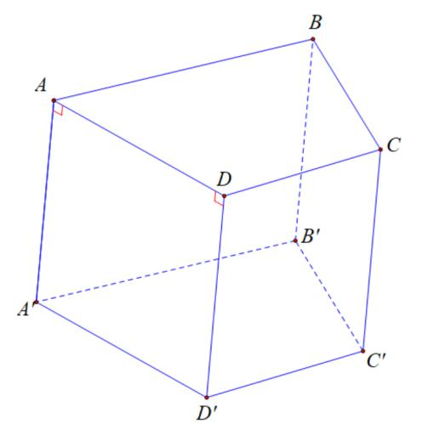
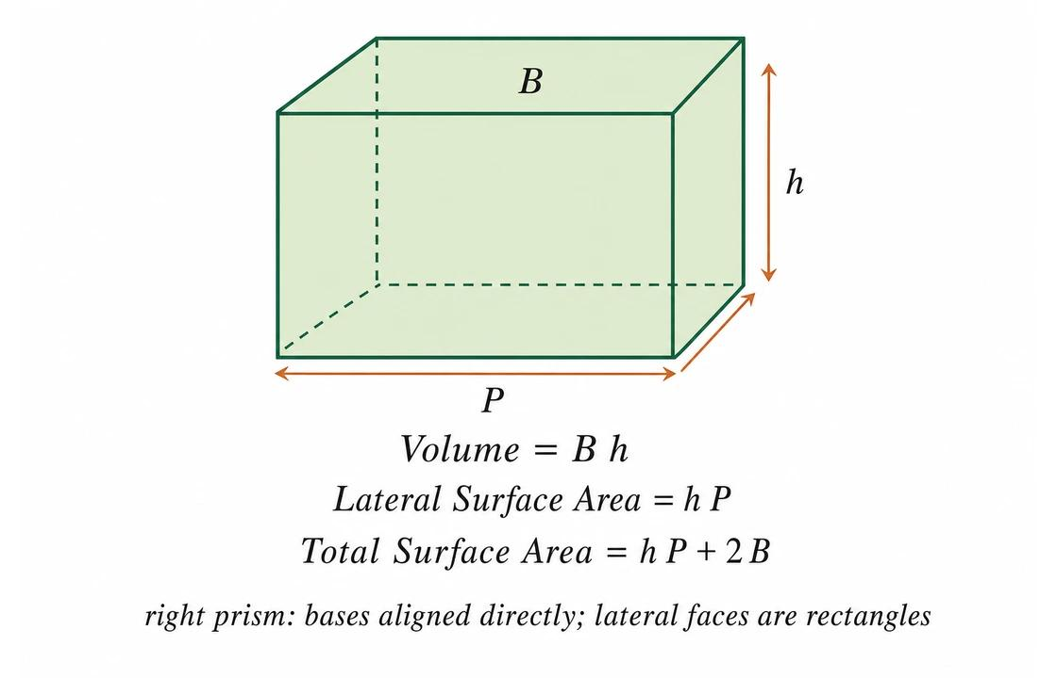
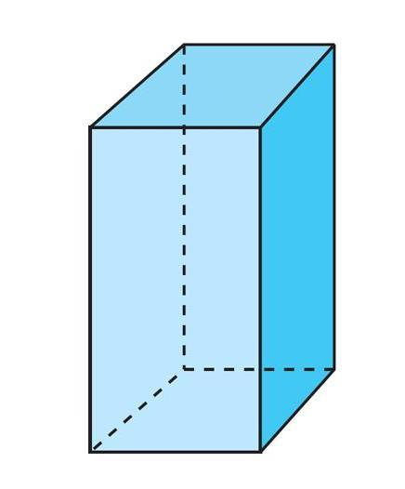

Definition
# Source: AI Source: Provided by: [Data Path: Persons Table -> ID Column: 1, Name_En Column: Motasem Essam] -> From: [ChatGPT] on [7/25/2026]
A right quadrilateral prism is a three-dimensional polyhedron with two congruent, parallel quadrilateral bases and lateral edges perpendicular to the base planes.
Because the lateral edges are perpendicular to the bases, all four lateral faces are rectangles.
The bases may be rectangles, squares, rhombuses, parallelograms, trapezoids, or other quadrilaterals. The term right describes the prism's spatial orientation, not the shape of its bases.
A right quadrilateral prism has:
- 2 congruent, parallel quadrilateral bases.
- 4 rectangular lateral faces.
- 6 faces in total.
- 12 edges.
- 8 vertices.

Simple Definition
# Source: AI Source: Provided by: [Data Path: Persons Table -> ID Column: 1, Name_En Column: Motasem Essam] -> From: [ChatGPT] on [7/25/2026]
A right quadrilateral prism is a 3D solid with two matching four-sided bases joined by straight side edges that meet the bases at right angles.
Its lateral edges are perpendicular to the bases, making the side faces rectangles.

Key Characteristics
# Source: AI Source: Provided by: [Data Path: Persons Table -> ID Column: 1, Name_En Column: Motasem Essam] -> From: [ChatGPT] on [7/25/2026]
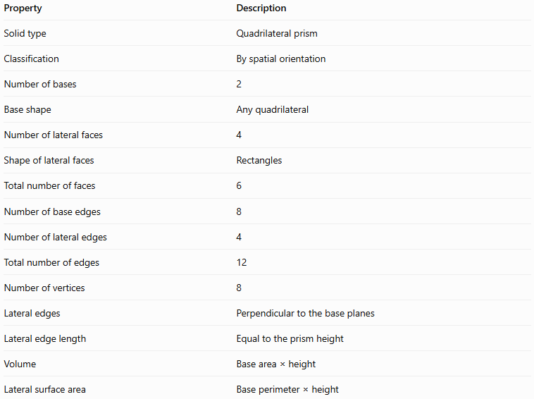
Property | Description
Solid type | Quadrilateral prism
Classification | By spatial orientation
Number of bases | 2
Base shape | Any quadrilateral
Number of lateral faces | 4
Shape of lateral faces | Rectangles
Total number of faces | 6
Number of base edges | 8
Number of lateral edges | 4
Total number of edges | 12
Number of vertices | 8
Lateral edges | Perpendicular to the base planes
Lateral edge length | Equal to the prism height
Volume | Base area × height
Lateral surface area | Base perimeter × height

Geometric Representation
# Source: AI Source: Provided by: [Data Path: Persons Table -> ID Column: 1, Name_En Column: Motasem Essam] -> From: [ChatGPT] on [7/25/2026]
The main components of a right quadrilateral prism are:
- Base faces: Two congruent, parallel quadrilaterals.
- Lateral faces: Four rectangles joining corresponding sides of the bases.
- Base edges: Eight edges in total, four on each base.
- Lateral edges: Four edges connecting corresponding vertices of the two bases.
- Vertices: Eight corner points.
- Height: The perpendicular distance between the base planes.
The defining feature is the right angle between every lateral edge and the base plane. The base itself does not need to be a rectangle.

Mathematical Representations and Formulas
# Source: AI Source: Provided by: [Data Path: Persons Table -> ID Column: 1, Name_En Column: Motasem Essam] -> From: [ChatGPT] on [7/25/2026]
Let:
- $B$ = area of one quadrilateral base.
- $p$ = perimeter of the base.
- $h$ = perpendicular height of the prism.
- $A_{L}$ = lateral surface area.
- $A_{T}$ = total surface area.
- $V$ = volume.

A. Number of faces, edges, and vertices
# Source: AI Source: Provided by: [Data Path: Persons Table -> ID Column: 1, Name_En Column: Motasem Essam] -> From: [ChatGPT] on [7/25/2026]
For a prism with an $n$-sided polygonal base:
$$F=n+2, E=3n, V=2n$$
For a quadrilateral prism, $n=4$:
$$F=4+2=6$$
$$E=3\left(4\right)=12$$
$$V=2\left(4\right)=8$$

B. Volume
# Source: AI Source: Provided by: [Data Path: Persons Table -> ID Column: 1, Name_En Column: Motasem Essam] -> From: [ChatGPT] on [7/25/2026]
The volume of any prism is its base area multiplied by its perpendicular height:
$$\boxed{V=Bh}$$
The base area $B$ depends on the type of quadrilateral used.

C. Lateral surface area
# Source: AI Source: Provided by: [Data Path: Persons Table -> ID Column: 1, Name_En Column: Motasem Essam] -> From: [ChatGPT] on [7/25/2026]
Because a right prism has rectangular lateral faces, each lateral face has one side equal to a base edge and the other equal to $h$.
Adding the areas of all four lateral rectangles gives:
$$\boxed{A_{L}=ph}$$
If the four base sides have lengths $a,b,c,d$, then:
$$p=a+b+c+d$$
Therefore:
$$\boxed{A_{L}=\left(a+b+c+d\right)h}$$

D. Total surface area
# Source: AI Source: Provided by: [Data Path: Persons Table -> ID Column: 1, Name_En Column: Motasem Essam] -> From: [ChatGPT] on [7/25/2026]
The total surface area includes the four lateral rectangles and both bases:
$$A_{T}=A_{L}+2B$$
Thus:
$$\boxed{A_{T}=ph+2B}$$

E. Special case: rectangular-base prism
# Source: AI Source: Provided by: [Data Path: Persons Table -> ID Column: 1, Name_En Column: Motasem Essam] -> From: [ChatGPT] on [7/25/2026]
If the base is a rectangle with length $l$ and width $w$, then:
$$B=lw, p=2\left(l+w\right)$$
The formulas become:
$$V=lwh$$
$$A_{L}=2h\left(l+w\right)$$
$$\boxed{A_{T}=2\left(lw+lh+wh\right)}$$
These rectangular-base formulas apply only when the base is rectangular; the general prism formulas apply to every right quadrilateral prism.

Worked Examples
# Source: AI Source: Provided by: [Data Path: Persons Table -> ID Column: 1, Name_En Column: Motasem Essam] -> From: [ChatGPT] on [7/25/2026]
Example 1: Counting faces, edges, and vertices
Problem: How many faces, edges, and vertices does a right quadrilateral prism have?
Since its base is a quadrilateral, $n=4$.
$$F=n+2=6$$
$$E=3n=12$$
$$V=2n=8$$
Answer: 6 faces, 12 edges, and 8 vertices.
Example 2: Calculating the volume
Problem: A right quadrilateral prism has a base area of $30{\text{ cm}}^{2}$ and a height of $9\text{ cm}$. Find its volume.
Using:
$$V=Bh$$
Substitute the values:
$$V=30\left(9\right)$$
$$\boxed{V=270{\text{ cm}}^{3}}$$
Example 3: Calculating the lateral surface area
Problem: A right quadrilateral prism has a base perimeter of $26\text{ cm}$ and a height of $8\text{ cm}$. Find its lateral surface area.
Using:
$$A_{L}=ph$$
$$A_{L}=26\left(8\right)$$
$$\boxed{A_{L}=208{\text{ cm}}^{2}}$$
Example 4: Calculating total surface area
Problem: A right quadrilateral prism has a base area of $24{\text{ cm}}^{2}$, a base perimeter of $22\text{ cm}$, and a height of $7\text{ cm}$. Find its total surface area.
First, calculate the lateral surface area:
$$A_{L}=ph=22\left(7\right)=154{\text{ cm}}^{2}$$
Then add the areas of the two bases:
$$A_{T}=A_{L}+2B$$
$$A_{T}=154+2\left(24\right)$$
$$\boxed{A_{T}=202{\text{ cm}}^{2}}$$
Example 5: Verifying Euler’s formula
Euler’s formula for a convex polyhedron is:
$$V-E+F=2$$
For this prism:
$$8-12+6=2$$
Therefore, Euler’s formula is satisfied.

Comparison with an Oblique Quadrilateral Prism
# Source: AI Source: Provided by: [Data Path: Persons Table -> ID Column: 1, Name_En Column: Motasem Essam] -> From: [ChatGPT] on [7/25/2026]
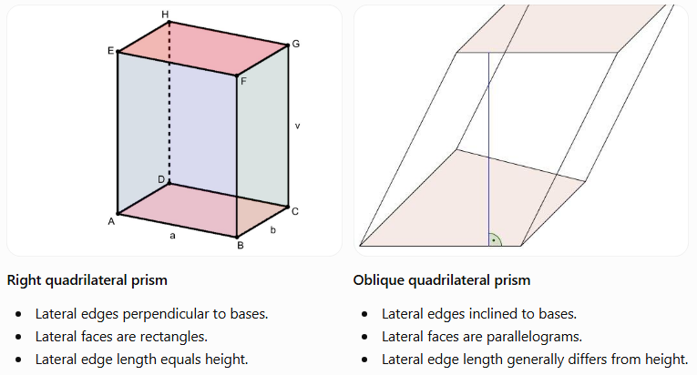
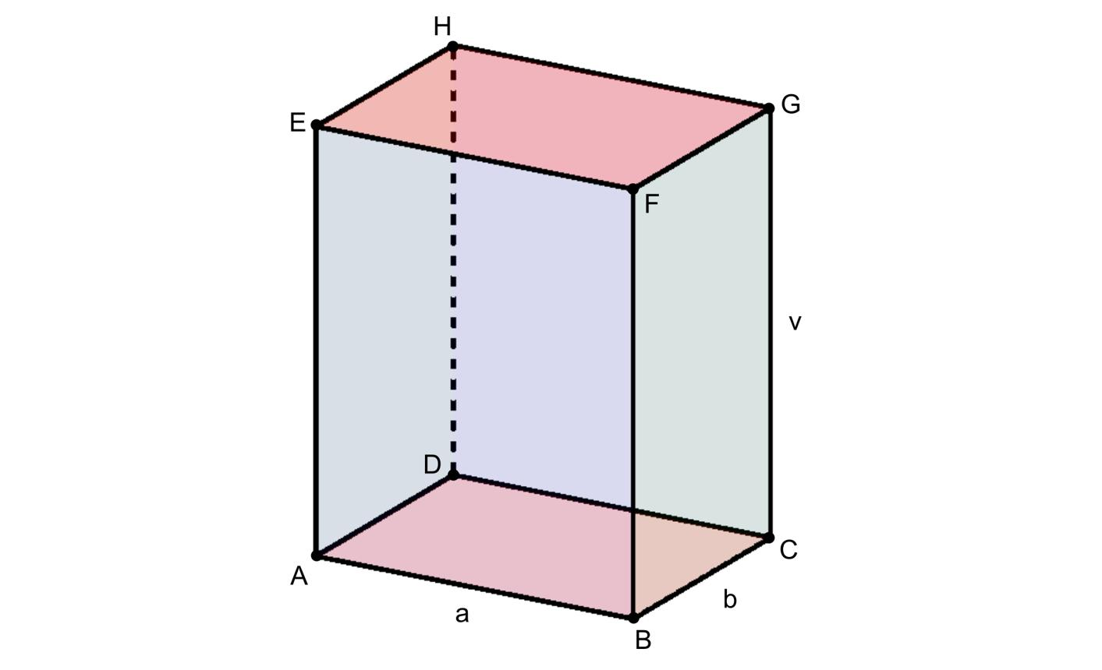
Right quadrilateral prism
- Lateral edges perpendicular to bases.
- Lateral faces are rectangles.
- Lateral edge length equals height.
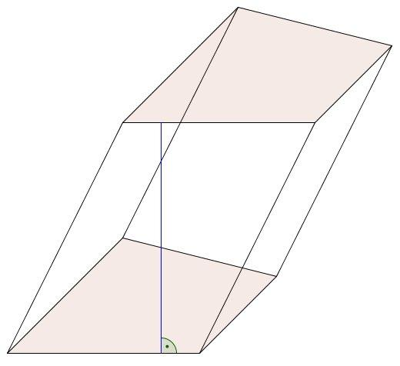
Oblique quadrilateral prism
- Lateral edges inclined to bases.
- Lateral faces are parallelograms.
- Lateral edge length generally differs from height.
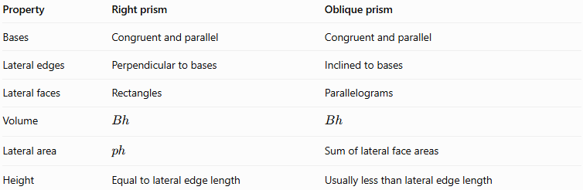
Property | Right prism | Oblique prism
Bases | Congruent and parallel | Congruent and parallel
Lateral edges | Perpendicular to bases | Inclined to bases
Lateral faces | Rectangles | Parallelograms
Volume | $$Bh$$ | $$Bh$$
Lateral area | $$ph$$ | Sum of lateral face areas
Height | Equal to lateral edge length | Usually less than lateral edge length
Both types have 6 faces, 12 edges, and 8 vertices.

Relationship to Other Quadrilateral Prisms
# Source: AI Source: Provided by: [Data Path: Persons Table -> ID Column: 1, Name_En Column: Motasem Essam] -> From: [ChatGPT] on [7/25/2026]
A right quadrilateral prism can be further classified by its base shape.
Right Quadrilateral Prism
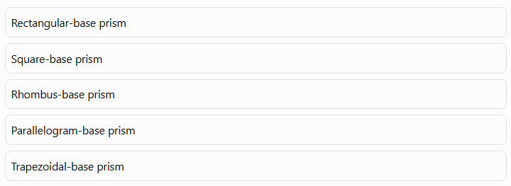
Rectangular-base prism
Square-base prism
Rhombus-base prism
Parallelogram-base prism
Trapezoidal-base prism
These categories describe the base shape, while right describes the orientation of the lateral edges. For example, a square-base prism can be right or oblique.
A cube is a special right square-base prism in which all edges have the same length.

Applications
# Source: AI Source: Provided by: [Data Path: Persons Table -> ID Column: 1, Name_En Column: Motasem Essam] -> From: [ChatGPT] on [7/25/2026]
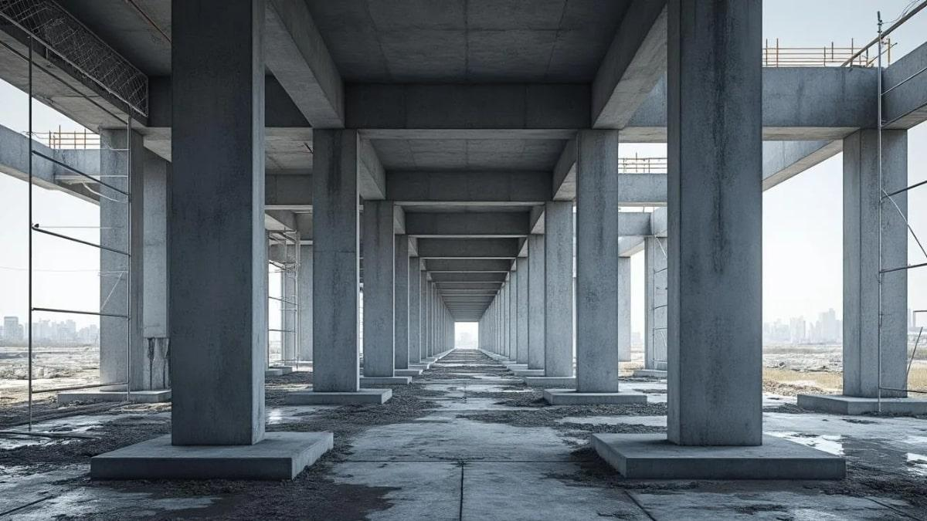
Architecture and construction
Right prisms model upright structural elements, columns, and many rectangular building components.
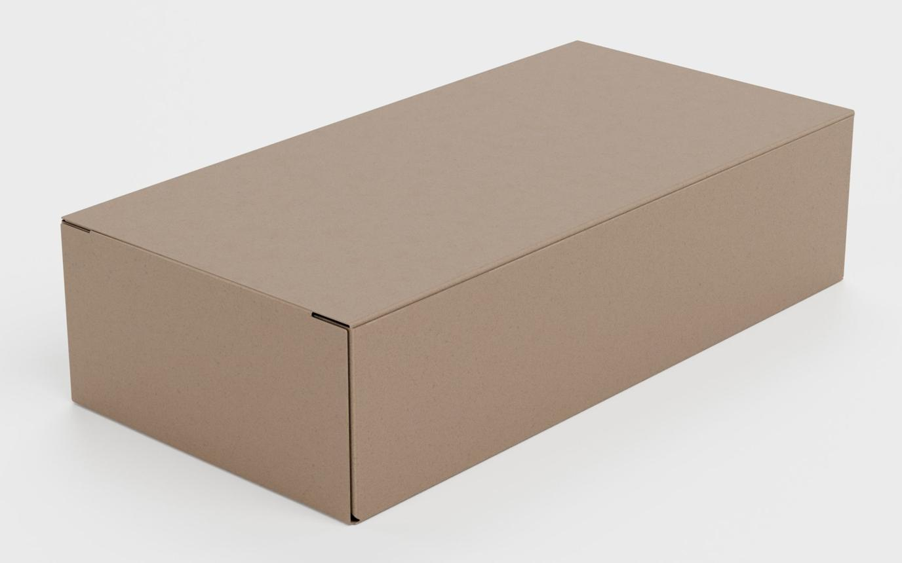
Packaging and manufacturing
They help calculate material requirements, surface areas, and internal capacity for prism-shaped objects.
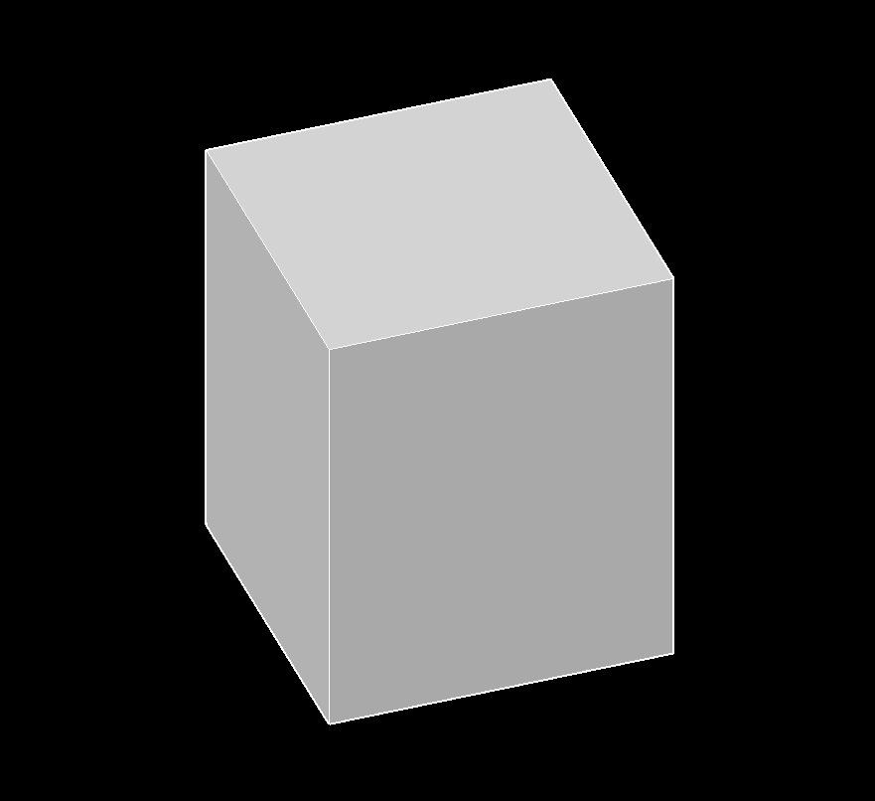
Engineering and 3D modeling
The perpendicular orientation simplifies geometric construction, measurements, and surface calculations.

Key Points
# Source: AI Source: Provided by: [Data Path: Persons Table -> ID Column: 1, Name_En Column: Motasem Essam] -> From: [ChatGPT] on [7/25/2026]
- A right quadrilateral prism has two congruent, parallel quadrilateral bases.
- Its lateral edges are perpendicular to the base planes.
- Its four lateral faces are rectangles.
- It has 6 faces, 12 edges, and 8 vertices.
- Its volume is $V=Bh$.
- Its lateral surface area is $A_{L}=ph$.
- Its total surface area is $A_{T}=ph+2B$.
- The shape of the base and the spatial orientation are separate classification properties.

Conclusion
# Source: AI Source: Provided by: [Data Path: Persons Table -> ID Column: 1, Name_En Column: Motasem Essam] -> From: [ChatGPT] on [7/25/2026]
A right quadrilateral prism is defined by the perpendicular relationship between its lateral edges and its base planes. This orientation makes all four lateral faces rectangles and simplifies the formulas for lateral surface area and total surface area. Although the bases can have different quadrilateral shapes, every right quadrilateral prism has six faces, twelve edges, and eight vertices.

